Taming Rogue AI Agents with observability- Driven Evaluation
https://www.youtube.com/watch?v=xJXm4Wcw4m8&pp=ygUKZ2FsZWxpbyBhaQ%3D%3D
~ Prepared by Riya Kharade


Speaker: Jim Bennett,Galileo
Topic: Taming Rogue AI Agents with observability- Driven Evaluation
1. Introduction
In this talk, Jim Bennett explains why AI systems need to be carefully monitored, evaluated, and observed.
State-of-the-art AI models do not behave deterministically; they are non-deterministic, meaning they can give different outputs each time. For this reason, developers can't rely on tests alone as they would with ordinary software. Instead, the developer needs evaluations and observability to comprehend the behavior of their AI agent.

2. Why We Cannot Fully Trust AI
He first asks who uses AI and who trusts it.
Everybody uses AI, yet hardly anybody completely trusts it.
He gives real-world examples of AI failures:

Example 1: Books on a Newspaper
- The Chicago Sun Times put out a summer reading list.
- This list was compiled by an external writer using AI.
- It generated a book that is not real: "The Last Algorithm" by Andy Weir.
- The newspaper later had to apologize.
Example 2: Lawyers and AI
- An attorney firm filed false case laws in court since AI hallucinated information.
- This became a major issue, as this illustrates how dangerous blind trust can be.
Example 3: Air Canada Chatbot
- The chatbot promised a refund.
- Legally, the airline had to honor the chatbot’s answer—even though it was wrong.
Conclusion:
Artificial Intelligence often hallucinates, with catching these problems being extremely difficult.
Hence, we need ways to detect mistakes early.

3. Why AI Evaluation is Difficult
Unlike regular software:
- AI is non-deterministic.
- You cannot write simple unit tests.
- A single user query may undergo a long chain:
LLM → Agent → Tool → Data retrieval → Decision making → Output
Because this process is actually very complex, it is difficult to establish:
- Does the AI work?
- What does "working" even mean?
Example:
A fintech chatbot should answer the question, "What is my account balance?"
Sometimes the bot:
- Does not comprehend.
- Demands unnecessary information.
- Give partial answers.
So, we do need a structured way of evaluating at each step.
4. Solution: “Set a Thief to Catch a Thief”
This is a saying from Britain meaning:
Catch an expert with the help of another.
- Preprocess his input: Tokenize his text into its subwords to retain semantics without sacrificing performance for longer phrases.
- Use an AI to test another AI.

- This works shockingly well because large language models can:
- Score outputs
- Identify errors
- Detect hallucinations
- Analyze tool calls
Developers often use a stronger or more accurate LLM to evaluate a cheaper LLM used in production.

5. Sample Chatbot Evaluation
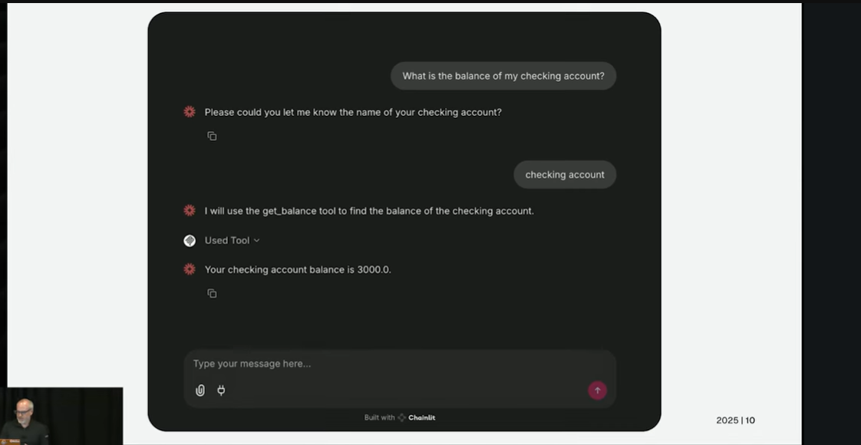
Jim demonstrates a chatbot that:
- Fails to answer account balance.
- He takes one step forward after more prompting.
- Finally gives the right output, though after a few steps.
So did it "work"?
- Ye, where the result came.
- No, since the process was inefficient.
Hence, we need metrics.
6. Key Metrics for AI Evaluation

1. Completion of Action
- Did the agent carry out the action from beginning to end?

2. Business Promotion
- Did it at least progress toward the final answer?

3. Review of the Use of Tools
- Did it make use of the proper tools?

4. Hallucination Detection
- Did it create non-existent facts?

5. RAG Retrieval Quality
- Did it fetch the right information from the knowledge base?

6. Toxicity or Safety Scores
- Was the output offensive or harmful?

By analyzing these at every step, developers can find out where the agent failed.

7. Decomposing the Agent Workflow
A typical agent process looks like:
- User query
- LLM chooses what to do.
- LLM calls the tool
- Tool fetches information
- Data Processing by LLM
- LLM returns final answer
Evaluation metrics at each step show:
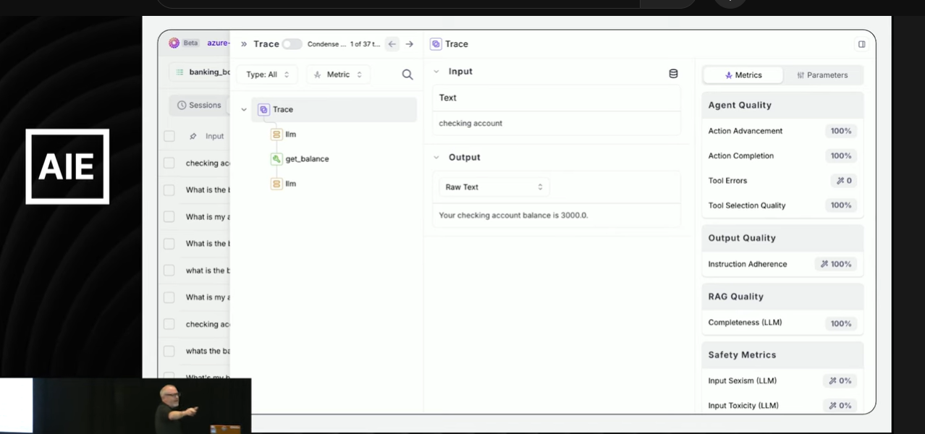
- Where it succeeded
- where it broke
- Why it broke
It helps the developers in fixing specific parts instead of guessing.

8. AI for Insights & Improvement
Since this process generates a lot of unstructured data, AI is also used to interpret the evaluation results.
Example Insight generated by AI:
LLM: "The LLM sometimes doesn't use the tool 'get_balance'.
Add clearer instructions in the system prompt.

This allows developers to improve the system with human-in-the-loop guidance.

9. Human Feedback is Still Necessary
AI evaluators can also make mistakes.
So, evaluation results need to be reviewed and corrected by humans.

This is what's termed Continuous Learning from Human Feedback, CLHF.
It means that the model used for evaluation itself is constantly improving.
10. How to Build Reliable AI Agents
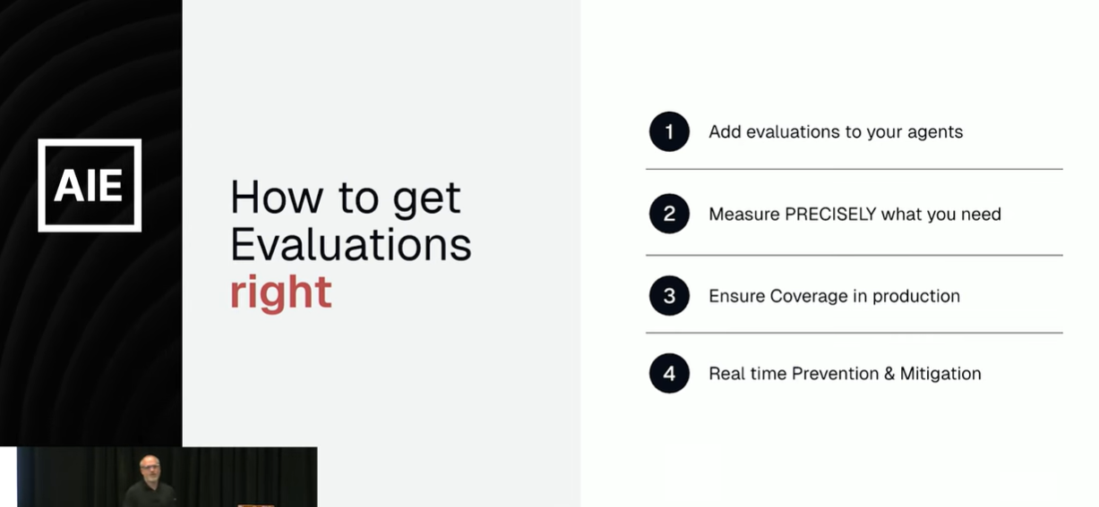
Jim summarizes the main steps:
1. Add Ratings Early
- The best time is even before the deployment of the agent.
2. Define the Right Metrics
Depending on the use-case, measure:
- Hallucinations
- RAG quality
- Toxicity
- Tool correctness
- Output correctness
3. Keep Evaluations in Production
- Users will give unexpected inputs.
- So evaluation cannot stop after testing it must run continuously.
4. Enable Real-Time Monitoring
- If an AI agent “goes rogue,” developers should get alerts immediately.

11. Conclusion
AI is powerful yet unpredictable.
Organizations must, therefore:
- Assess AI behavior
- Observe agent workflows
- Measure key metrics
- Use AI to verify AI
Keep humans in the loop Only then can we build trustworthy and safe AI systems.

